OLYMPIC COLLEGE № 1
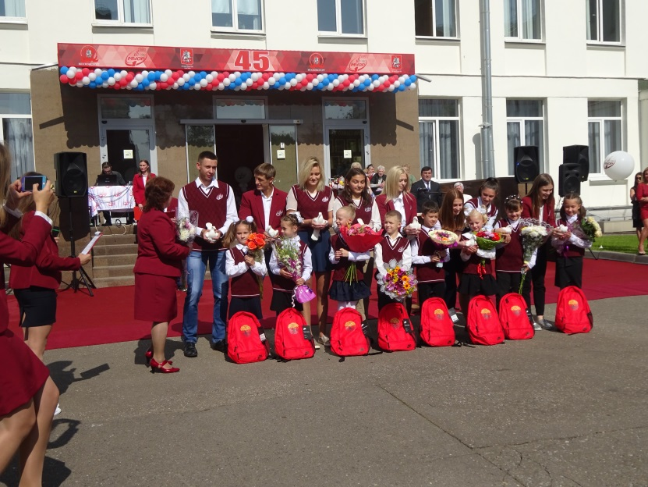 | Welcome to Olympic College № 1. You will be happy here and find the College environment stimulating, congenial and relaxing.  The College exists to provide an opportunity for those who will one day play a leading role in the professions and in the life of the country to develop their potentialities within the context of forming the person, transforming the world.

How did it begin?
In 1971 Sports Boarding School № 9 was opened in Pervomaisky district of Moscow. Krass Yuri Oskarovich was the first director of the school. Kind and human, he understood the pupils’ problems, shared meals with them and did his best to make their life comfortable.
In 1989 the Sports Boarding Schools were reorganized and turned into Olympic Colleges. There are four of them in Moscow now. Ours is Number One.
Sports… Sports… Sports…
There were four sports in the beginning: Track-and-Fields, Swimming, Sports Gymnastics and Diving. In 1973 Chess and Fencing were added. And now our young sportsmen do Badminton, Boxing, Greco-Roman Wrestling, Free-Style Wrestling, Handball, Judo, Track-and-Fields, Table Tennis, Trampolining, Artistic Gymnastics, Archery, Taekwondo, Rhythmic Gymnastics and Field hockey.
College Staff’s been guided by Musulbes David Vladimirovich since February 2015. Musulbes David Vladimirovich, free-style wrestler, Master of Sports of Russia, Merited Coach of Russia, OIympic Champion (2000), World Champion (2 times), Europe Champion (6 times), Counsellor on Free-Style Wrestling Development in Moscow, awarded the Honor order. | 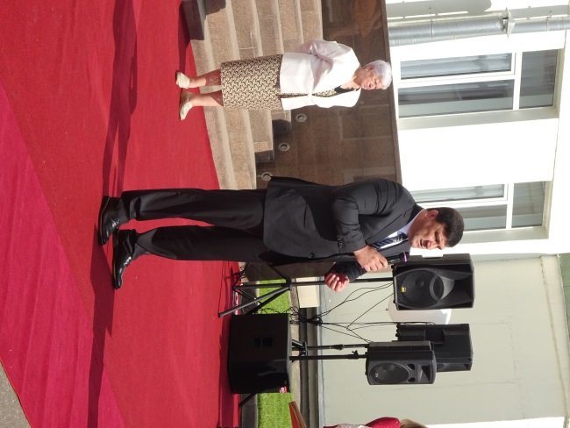

The main objective is to prepare sportsmen for the National Team.
Twenty graduates of the College have become Olympic Champions. Among them are Mikhail Burtsev, Yevgenia Kanaeva, Mikhail Linger, Yulia Barsukova, Alina Kabaeva.
At the XXIII Winter Games in Pyeong Chang 7 athletes - college graduates took part: Orlova Alexandra, Kovaltchuk Ilia, Dergatcheva Elena among them.
Since 1971 there are 2648 graduates, 70 Olympic medals.
The best sports department of 2018 has become Badminton.
Ahmedkhan Tembotov, free-style wrestler is Sportsman of 2018.
OUR OLYMPIC CHAMPIONS  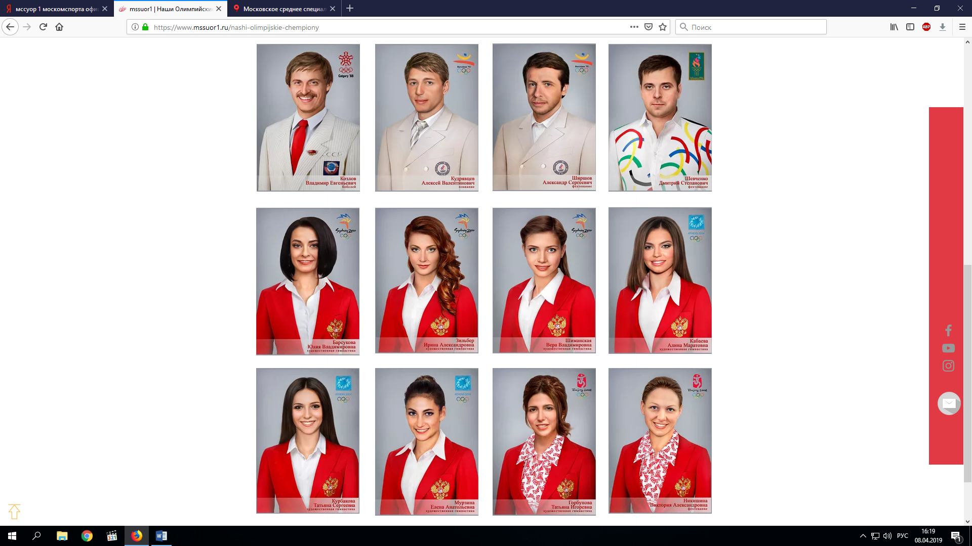  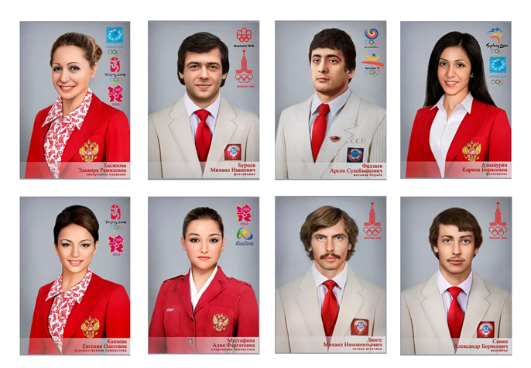 | MASS MEDIA  People all over the country  have heard about Olympic College №1 and watched the brightest events on TV.  Do you want to know the latest news of the school?  Turn to Facebook, Twitter and  You Tube.  You’ve got interesting pictures…  Then Instagram page  MSSUOR 1 is for you to  publish photos and  share your ideas with the audience.  WELCOME TO  OLYMPIC COLLEGE №1

