SCRABBLE
Adamanis Yaroslava, 6-B,
secondary school №3 Orenburg
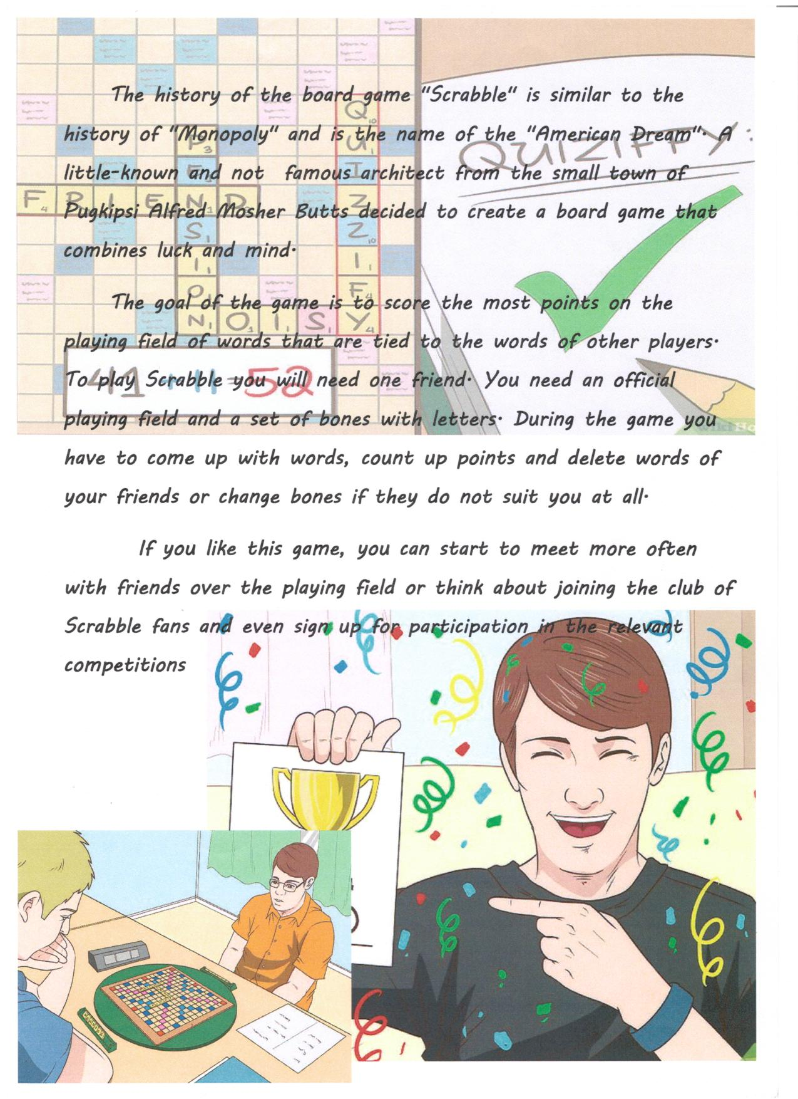
Teacher: Klunova Valentina Alekseevna

